03.01
PLANNING
Process Design & AMOS Configuration Document
Purpose
This Process Design document is provided to Key-Users to record their key decisions regarding the AMOS Process design and the required AMOS configuration.
It is updated throughout the Project Definition Phase and used as the baseline for the Final Acceptance prior to Go-Live
Revision
Author, Name | Date | Notes
Adriano Azzurretti | 01.06.2024 | First Version

Table of Contents

1. Process Overview & Objectives 3
2. Regulatory References 3
3. Definitions & Glossary 3
4. Process Tasks 4
5. Process Dependencies 4
6. Process Flow 5
7. Process Design Questions 7
8. Data (Source) Mapping 9
9. Other Software Used 9
10. AMOS Configuration 10
a. Basic Data 10
b. Parameters 10
c. Workflows 13
d. Scheduled Tasks 13
e. API’s & Interfaces 14
11. UAT Guidance 14
12. Annex – Additional Info 14

Process Overview & Objectives

Process General Description:
The process covers the management and control of the continuous airworthiness of the fleet, including constituent assemblies and components, through the planning of maintenance layovers in which to perform the maintenance tasks due.
Main drivers for the generation of maintenance layovers are the aircraft availability for maintenance (available slots), the maintenance requirements due dates and their interval's utilisation.
Main Process Objective (Outputs & Outcomes):
Output of this process is an updated maintenance layover plan matching all the operational, technical and airworthiness constraints, and spanning over a given timeframe.
Please note that the planning process can - and should, especially for larger fleets operators - be performed on several different timeframes (e.g. Long, Medium and Short Term), each with different scopes (e.g. 12 years-, 6-years- and C-checks-compatible Base Maintenance and major components replacement; Base Maintenance checks with interval below the C-check and minor modifications; line maintenance checks and tasks; etc.). This business process covers the different cases mentioned above.
Keeping the maintenance plans aligned and up to date in case of their changes / shifting due to operations or maintenance disruptions is considered a significant part of this Business Process.

Regulatory References

- EASA Part M - Subpart B M.A.201 Responsibilities
- EASA Part M - Subpart C M.A.301 Continuing airworthiness tasks
- EASA Part M - Subpart C M.A.303 Airworthiness Directives
- EASA Part CAMO - CAMO.A.315(b)(5) Continuing airworthiness management
- FAA Title 14 CFR § 121.363 Responsibility for Airworthiness
- FAA Title 14 CFR § 91.405 Maintenance Required
- FAA Title 14 CFR § 91.409 Inspections

Definitions & Glossary

Key-Words | Explanation
Work Package | An object representing a Maintenance Layover in AMOS, which can then contain the maintenance events to be performed during the layover itself
Leading Event in a Work Package | The check, the engineering document or the task that requires the longer ground time and/or the more resources in a work package. In the maintenance plans generation and update, it is the pivotal event of the maintenance layover, around which the work package content is built adding out-of-phase events or minor maintenance checks.
Maintenance Item / Maintenance Event | A scheduled or unscheduled maintenance task to be performed on the aircraft

Process Tasks

Business Process Task / Actions / Activities:
- Review of the relevant maintenance events in the Maintenance Forecast on the respective planning horizon
- Review and update of the daily aircraft utilisation (seasonally)
- Generation of a work package based on the due values of the leading event and the available ground time for maintenance
- Assign planning attributes to a work package (e.g., station, maintenance provider, planned start/end time, drop-off location, financial project, applicable maintenance program revision, etc.)
- Assignment of maintenance items to the work package
- Realignment / update of the maintenance plan in case of its shifting due to operations or maintenance disruptions
- In case of shifting of the maintenance plan, review delayed work packages' content to identify and manage upcoming criticality in terms of overdue maintenance items

Process Dependencies

Input
- AMOS Business Processes 01.03 – Maintenance Program, 01.02 – Parts Definition, 01.04 – Documents Assessment, 08.03 – Defect Reporting and Deferral, 03.04 – Modification Campaigns: Plannable events are generated by these Business Processes – respectively for Task Cards and Checks, Parts Requirements, Engineering Documents, Defects – and are made available for the planning process
Connected
- AMOS Business Process 08.02 – Performing maintenance: Any disruption arising during the performance of a maintenance and leading to a change in the planned ground time may require a realignment of the Maintenance Plans
Output
- AMOS Business Process 03.02 – Work Package Generation: Business process 03.01 - Planning concerns the aircraft reservation for maintenance with the creation of Work Packages, each driven by a leading event. The assignment of maintenance items other than the leading events is performed as a second step within Business Process 03.02 – Work Package Generation.

Process Flow

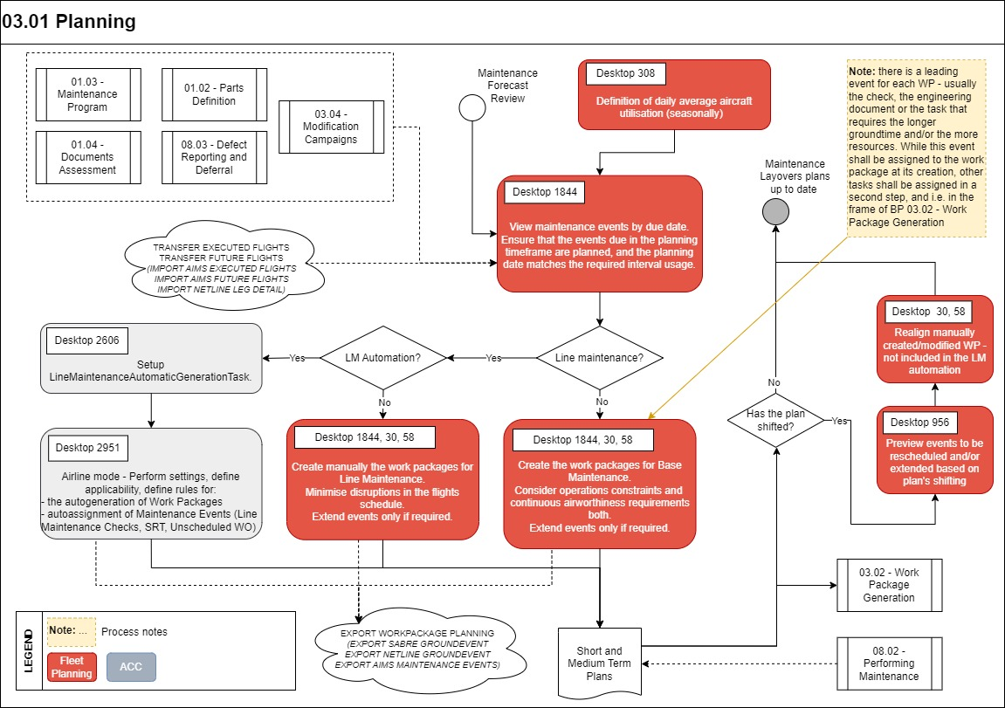
Process Flow Notes:
- Concept of "leading event" for each layover: usually the maintenance check, the engineering document or the maintenance program task that requires the longer ground time and/or the more resources
- Drivers for the Maintenance Planning Process are usually different between:
  - Line Maintenance layovers: to perform tasks with (typically) shorter interval, planned during short transit time between two flights or overnight, in the APRON
  - Base Maintenance layovers: to perform tasks that may or may not have a longer interval, planned overnight or during longer transits, however in a hangar
- Flights can – and should – be imported from the Flight Ops. System using the available APIs
- Maintenance layovers can – and should – be exported to the Flight Ops. System using the available APIs
- The AMOS Line Maintenance Automation features allow the automated creation of line maintenance work packages according to customisable rules settings, and their synchronisation in case of changes in the flight operations schedule

Process Design Questions

# | Question | Answer
1 | What are the responsible departments for the Maintenance Plans in your organization?
2 | Where are these departments allocated?
3 | How are these departments organized internally? (e.g., short/long/medium term, wide/narrow bodies, ATA chapter…)
4 | Does the average aircraft utilization change seasonally?
5 | Who oversees the setting of the average aircraft utilization used for the calculation of the next due dates of maintenance events with interval other than calendar days?
6 | How is the fleet availability for maintenance defined?
7 | Do you use contracted maintenance providers for Base Maintenance and/or Line Maintenance?
8 | How long in advance are maintenance layover created for base maintenance? And for line maintenance? Is there any relevant difference in the Service Level Agreements for external maintenance providers?
9 | How do you exchange information about your fleet’s maintenance layovers with your Flight Ops. Department?
10 | How often do you revise your maintenance plans? Is there any standard interval?
11 | Is the availability of the (internal) MRO resources a driver for the planning of maintenance layovers?
12 | Are you going to use the AMOS Line maintenance Automation? At what extent?
13 | Are you going to use Work Packages for Line Maintenance?
14 | What is your Flight Operations software? Are you going to transfer flights and maintenance layovers between it and AMOS via an automated interface? What will the scope of this interface be in terms of timeframe?

Data (Source) Mapping

Data Sources | Description | Volume / Manual / Automatic / Static / Dynamic

Other Software Used

Other Softwares | Used by: | Description

AMOS Configuration

APN 1844 – Maintenance Forecast: Please make sure to show the column “Yield” in the Forecast Display in order to see the interval utilisation.

Basic Data

Basic Data Table | Notes
Time Requirement Defaults | Defines the default Time Requirement Next Due Calculation Strategy for different kind of maintenance events
Maint.Event Extension Code | To define codes for Reduction, Extension and De-assignment (together with parameter 1110 to enter the de-assignment reason)
Workpackage Priority Code | To define the priorities of your work packages.
Priority | All workorders have a priority. Default priorities range between 1 for highest priority to 5 for lowest priority including some special priorities are defined in this table.
Groundtime Extension Reason | This table is used to specify the reason why a work package can be extended. When extending a work package it is mandatory to choose from one of these Codes.

Parameters

Parameter Code | Parameter Name | Notes | Comments / Decisions
857 | INITIALIZE FUTURE EVENTS | This parameter informs the system if future events should be initialized | Int = 5,  Float = 1095,  String = Y
1427 | AMOUNT OF DAYS TO SHOW ON WP BROWSER BUTTON | With this parameter you can set the number of days that are shown on the button on the right of the TODAY button in APN 30 - Workpackage Browser | Int = 3,  String=N
1502 | Workpackage Date | Integer value: In Maintenance Forecast the workpackages are normally filtered by start date. This means that all workpackages are listed that start between the selected history date and the selected future date. This is fine if most work packages have a short duration. But for MRO providers with mostly having heavy checks lasting over several weeks, these workpackages always disappear from Maintenance Forecast. Therefore by setting the Integer value to 1, you can display the work packages ending after the history date but start before future date.  String value: The String value defines the default start time and the duration of a work package. The values must be separated by semi-colon (;). The first value stands for the default start time for any newly created work package and the second value stands for the duration. If the duration is negative, the default values (see below) will be used.  Float value: When the float value is 1.0, the default start time and duration defined in the string value will always be used to create a work package. | Int = 0,  Float = 0.00,  String = 22:00;7
1523 | WORKPACKAGE ASSIGNMENT RESTRICTIONS | To define if a warning message should be displayed whenever a workorder classified as heavy is assigned to a workpackage classified as line | Int = 1,  String = Y
1537 | Default workpackage classification | Default workpackage classification: H = Heavy; L = Line; I = Hidden (Invisible); U = Unclassified | String = U
1650 | Workpackage Number Index | This parameter controls the automatic generation of workpackage numbers when creating work packages.  When the integer value is > 0, an index will be appended to the generated work package numbers instead of the date. When the string value is not empty it will be used as a pattern.  Float value: Contains the next index that will be appended. Only the integer part of this number is considered; it is automatically incremented by AMOS.  Integer value: This value defines to how many digits the index number will be formatted (padded with zeros on the left). This index is used only if the pattern in the string value is empty.  String value: Contains the pattern used generate the number of work packages with known A/C [See APN 1442 for a complete list of variables available]. | Default values:  Int = 0,  Float = 0.00,  String = ‘’
1653 | Forecast calculation parameters | Integer value (value in hours, value less than zero=disabled). Define a minimum Workpackage groundtime in hours to be considered as non-flying time in the expected date calculation of maintenance events. In case a Workpackage groundtime is equal to or exceeds the defined amount in this parameter, this groundtime will be considered as non-flying time in the expected date calculation of Flight Hours (FH) and Flight Cycles (FC) for maintenance events which are due after the start date and time of the Workpackage. Workpackages ground times are only considered for the time range where the expected date is calculated based on daily average. For the time range where the expected date calculation is based on future flights, the Workpackage ground time is not considered.  Double value (value in days, value not defined or less than zero = default value = 15 days). It defines the number of days considered so that the forecast entries are flagged as "to be recalculated" after a counter update. This number of days is added to the current date in order to find the forecast entries for which the expected date is lower than the targeted date calculated.  String value (value not defined or not a number format = default value = 200): During the forecast calculation of Part Replacement events, the system has to consolidate all rotables from the assembly tree and therefore has to handle a large list of PSNs. In order to improve the performance of database queries based on this list of PSNs, queries are split in sub-queries of a limited amount of PSNs. This parameter defines the maximum number of PSNs to be considered by each sub-query. WARNING: this value must be defined with care because it has a significant impact on the performance. It must not be changed, unless it has specifically been recommended by Swiss AS. | Int = 24,  Float = 15.00,  String =200
1687 | Activate the NullLegsFiller daemon | The activation of the NullLegsFiller daemon impacts the calculation of the next due date (using counters other than calendar days) for those aircrafts with days in the past with no flight activity. Without null leg, the average daily values are applied for those days in the forecast computation. | String = Y

Workflows

Workflow Number | Workflow Name | Notes
43 | Publish a Workpackage
98 | After saving, deleting and creating a Workpackage
158 | After deassigning Events from a Workpackage
307 | Before assigning Events to a Workpackage
325 | Before saving, deleting and creating a Workpackage
370 | After assigning Events to a Workpackage
371 | Before deassigning Events from a Workpackage
409 | Dataset Notification | Only if WP transfer via API is used
484 | Workpackage changed

Scheduled Tasks

Scheduled Task Reference | Frequency | Notes
Forecast Sequence, including:  EffectivityApplicabilityService  EffectivityConsistencyTask  RecalculateFutureEventsService  CheckExpiredSoftwaresTask  AircraftMaintenanceForecastService  ComponentMaintenanceForecastService  PartForecastService | Daily

API’s & Interfaces

Reference | Direction | Trigger | Frequency
TRANSFER EXECUTED FLIGHTS | Import | Scheduler Task or Webservice | Every 2-5 mins.
TRANSFER FUTURE FLIGHTS | Import | Scheduler Task or Webservice | Every 2-5 mins.
IMPORT AIMS EXECUTED FLIGHTS | Import | Scheduler Task or Webservice | Every 2-5 mins.
IMPORT AIMS FUTURE FLIGHTS | Import | Scheduler Task or Webservice | Every 2-5 mins.
IMPORT NETLINE LEG DETAIL | Import | Scheduler Task or Webservice | Every 2-5 mins.
EXPORT WORKPACKAGE PLANNING | Export | Workflow (43, 98 or 484) or Scheduler Task | Every 2-5 mins.
EXPORT SABRE GROUNDEVENT | Export | Workflow (43, 98 or 484) or Scheduler Task | Every 2-5 mins.
EXPORT NETLINE GROUNDEVENT | Export | Workflow (43, 98 or 484) or Scheduler Task | Every 2-5 mins.
EXPORT AIMS MAINTENANCE EVENTS | Export | Workflow (43, 98 or 484) or Scheduler Task | Every 2-5 mins.

UAT Guidance

Annex – Additional Info

